**Window Object**

Window object referee to the browser window it’s the default object for the browser, window object consist of properties & methods. It was supported in all browsers, but there are some of its properties & methods not supported in all browsers.

**Note:** All objects present in JS considered members for window object.

As any object consists of methods and properties also window object has methods and properties:

**First: window methods.**

|  |  |
| --- | --- |
| **Method** | **Description** |
| **Window.alert(‘alert message’)** | This function used to pops **alert** **message** with **ok** button. Window makes full focus on alert box so you can’t do anything until hide the alert box. [**Note:** use this function wisely] |
| **Window.prompt(‘Question’)** | This function is used to pops an input field (so it has a default value) to fill some information and return these information as ***string*** that can be used with another functions. |
| **Window.confirm(‘Confirmation message’)** | This function used to pops **Confirmation message** about doing some action with **ok** and **cancel** buttons returns Booleans data where **ok** returns **true** while **cancel** returns **false**. Window makes full focus on alert box so you can’t do anything until hide the alert box. |
| **setTimeOut(function, ms)** | This function is used to set Descending counter in milliseconds, after end it a specific function will be executed only ***one*** time. |
| **clearTimeout(Id of timeout)** | This function is used to stop the Descending counter which stetted by setTimeout() function. |
| **setInterval (function, ms)** | This function is used to set Descending counter in milliseconds, after end it a specific function will be executed ***several*** time. |
| **clearTimeout(Id of interval)** | This function is used to stop the Descending counter which stetted by setInterval() function. |

**Example:** on alert(), confirm(), and prompt() functions.

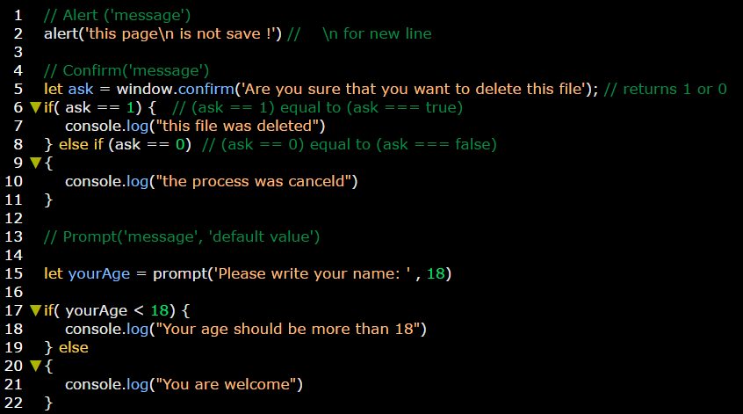

**Example:** on setTimeout & clearTimeout functions.

